Login to PLYSSQL146D.

Open SQL Server Management Studio.

Select the database **Allergan.**

**Generating History Data:**

1. Run the below query.

This will display the latest Data Month name for Belgium. Here, latest month is M112012.

select * from Allergan_Load_Details where country = 'BE'

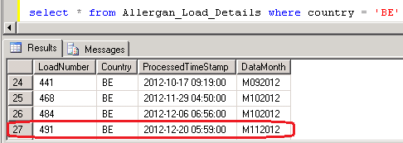

2. Run the Below query with the Latest Data Month Load Number.

This will display the backup data of M112012 Which was loaded in last production run.

select * from Allergan_Output_History where loadNumber = 491

3. Run the Below SP which will load the latest production period data from Production

Server (PLYSSQL147P) to Development Server (PLYSSQL146D)

EXEC dbo.usp_Populate_History_Data_DEV_PROD 'BE','MmmYYYY'

where mm = Current Production Month Number (01, 02, ... 11,12)

and YYYY = Current Production Year.

4. Run the below query to check whether the latest production period data loaded or not

select * from Allergan_Load_Details where country = 'BE'.

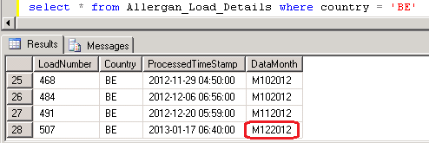

5. Run the **MergePacks.exe** from D:\FTP\MergePacks tool\

6. Click on Build Report

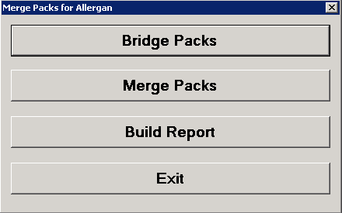

7. Select Country = BE and Previous Build = Previous Month. Click OK

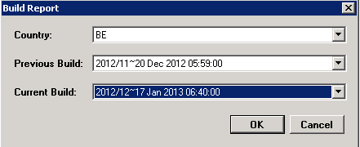

8. After successful run Below window will appear and the History Correction Report will generate at D:\FTP\MergePacks tool\Reports

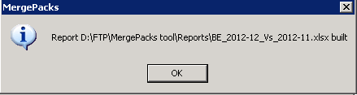

9. Copy the report file and backup at D:\FTP\MergePacks tool\Reports\YYYY\YYYYMM

where MM = Current Production Month Number (01, 02, ... 11,12)

and YYYY = Current Production Year.

10. Download the history excel file into Local and rename

History_Corrections_Belgium_monYYYY.xlsx

where mon = Current Production Month Name

and YYYY = Current Production Year.

This file should mail to Allergan with delivery mail.

**Input CUBE vs Output Data:**

1. Vermeersch, Sara (Brussels) send the input SA cube XTR and PTR data available confirmation mail with the location at \\imsuklndsi15\tpdata\Abhay\Allergan\Belgium SA. 2 input SA Cube **ALLERGAN B 000200 XTR STD XTALLO01_19961__YYYYMMDD.zip** and **Allergan B C18000 PTR MALL01PT_14686__20121215.zip** should be load in 162.44.12.72 server

2. Login to 162.44.12.72 server.

3. Copy the output file **Belgium_MMYYYY.csv** from production server (PLYSSQL147P) D:\FTP\Allergan_Production_Output\Renamed_Outputs and paste at the location \\162.44.12.72\d$\Allergen\Belgium\YYYYMM

where MM = Current Production Month Number (01, 02, ... 11,12)

and YYYY = Current Production Year.

4. Open **Database Installer** from **Start -> All Programs -> IMS Health**

5. Click **Select** and select the **XTR** cube **ALLERGAN B 000200 XTR STD XTALLO01_19961__YYYYMMDD.zip** and click **Open**

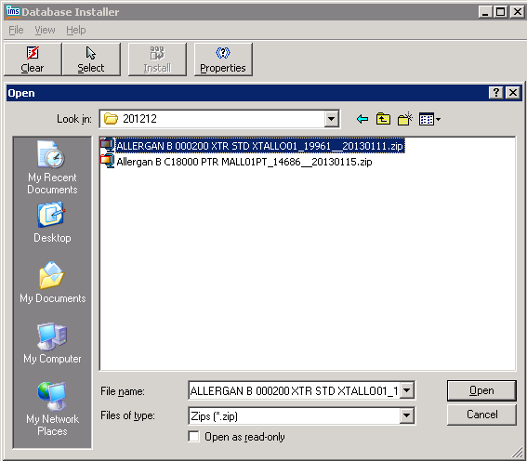

6. Select the Cube and Click **Install**

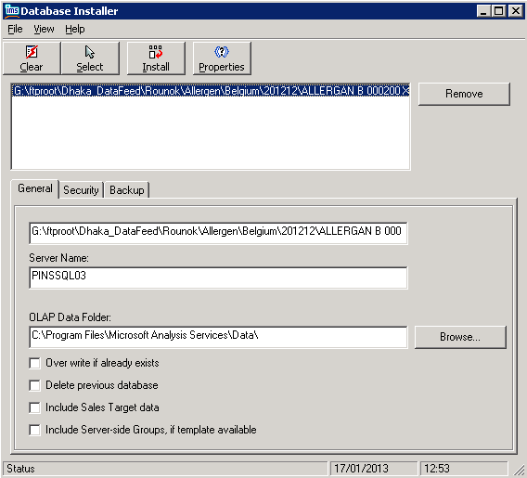

7. When the cube loaded successfully below message window will appeared.

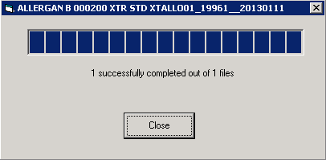

8. Load the PTR Cube **Allergan B C18000 PTR MALL01PT_14686__20130115.zip** with following step 5 - 7 .

9. Open **Analysis Manager** from **Start -> All programs -> Microsoft SQL Server -> Analysis Service**

9. Select the required Cube and Click **Data**

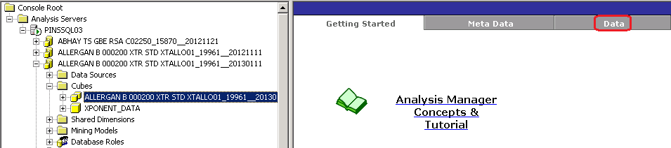

10. Below window will appear. Click ok to Continue

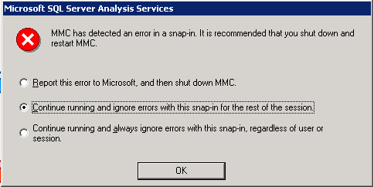

11. Click **Data** again.

12. From Period select the latest production period

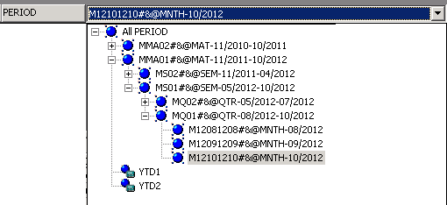

13. Drag the Product.MKT to the Result Area. This will remove the Geography

|  |  |
| --- | --- |
|  |  |

14. Open the output csv file **Belgium_MMYYYY.csv** with Textpad. Select 3 records for 3 measure Counting Units, Units and Values for a particular Product and SKU which have >0 values in latest month

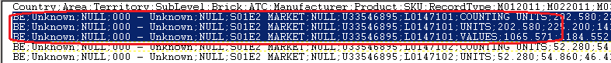

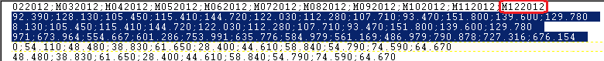

15. Copy the records and paste into a new text file and save the file as QA_Belgium_YYYYMM.txt at the location G:\ftproot\Dhaka_DataFeed\Rounok\Allergen\Belgium\YYYYMM

where MM = Current Production Month Number (01, 02, ... 11,12)

and YYYY = Current Production Year.

16. Select the Area , Territory and Brick from **Geography.Geo** according to the input record

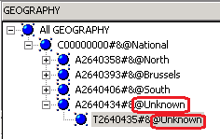

17. Select Market, Products, Packs from Product.MKT according to the input record

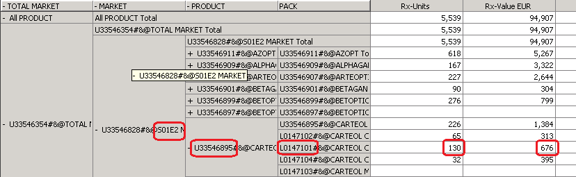

18. Match the value for input SA Cube and Output CSV.

**Summary File Checking**

1. Open the Summary File **Belgium_Summary.txt** from Production Server (PLYSSQL147P) from the location D:\FTP\Allergan_Production_Output with TextPad

2. Check the ratio with the Previous month vs Current month.

3. Check if the ratio decrease of previous vs current for any measure, rest 2 will decrease also

BE;S01E2 MARKET;NULL;U33546829;COUNTING UNITS;**37951.330;36255.270**

BE;S01E2 MARKET;NULL;U33546829;UNITS;**12688.510;12125.990**

BE;S01E2 MARKET;NULL;U33546829;VALUES;**249053.803;237934.568**

4. Check if the ratio increase of previous vs current for any measure, rest 2 will increase also

BE;S01E2 MARKET;NULL;U33546845;COUNTING UNITS;**5476.280;5531.100**

BE;S01E2 MARKET;NULL;U33546845;UNITS;**5476.280;5531.100**

BE;S01E2 MARKET;NULL;U33546845;VALUES;**22592.482;22817.525**